**All the tested prompt used and obtain output are below: all the figures are the obtained output.**

* **GUI Interface**

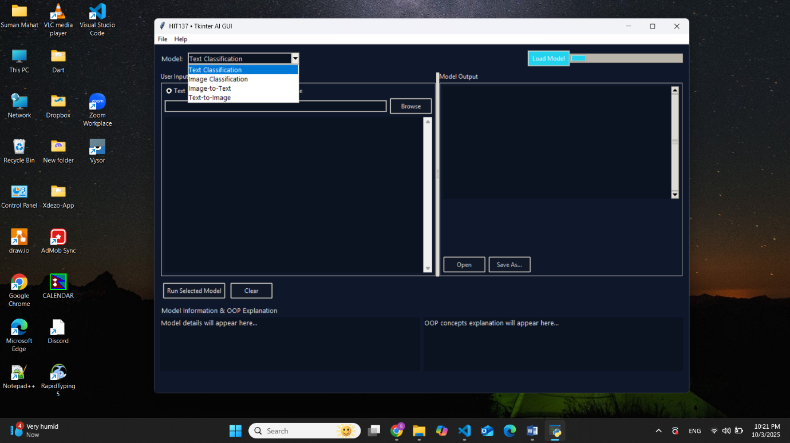

Figure 1: GUI Interface

* **Model: Text Classification**

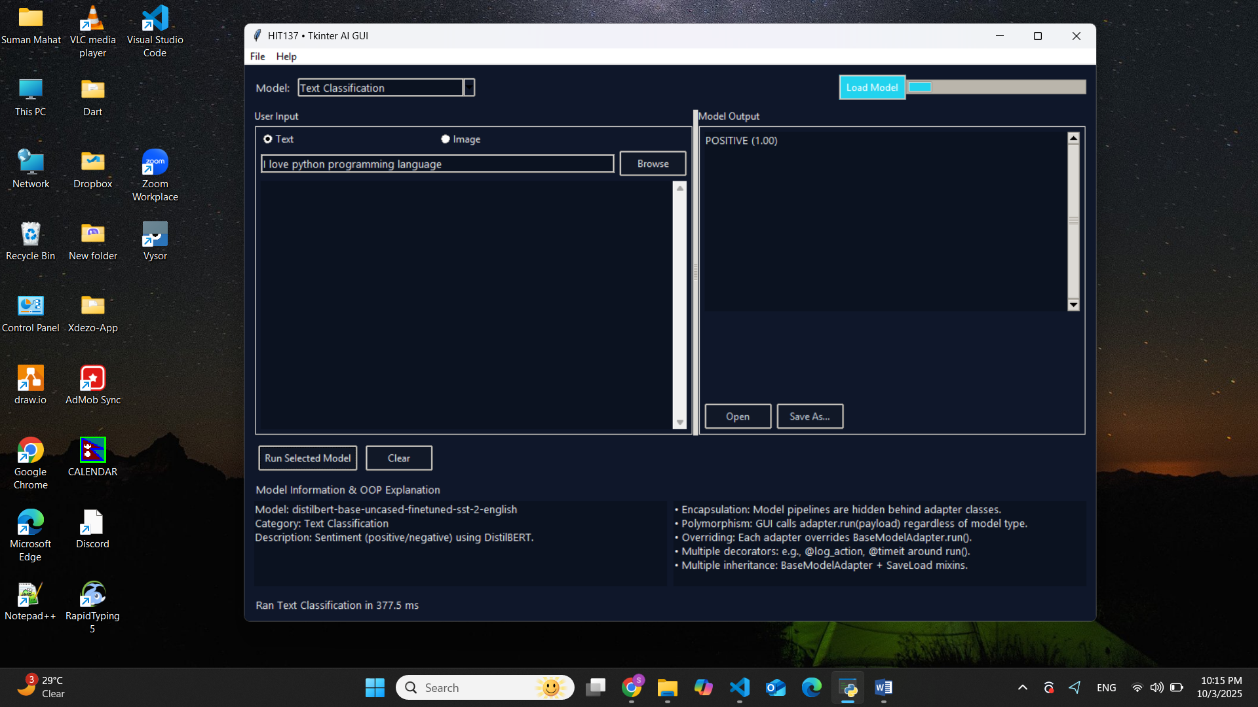

Figure 2: Text Classification Model Output (i)

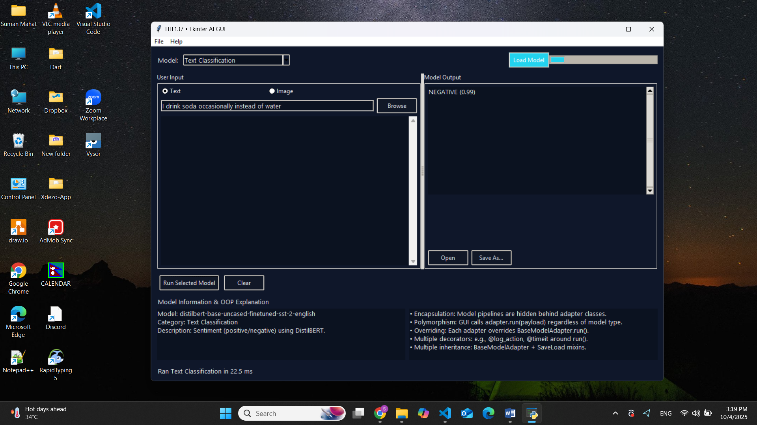

Figure 3: Text Classification Model Output (ii)

* **Model: Image Classification**

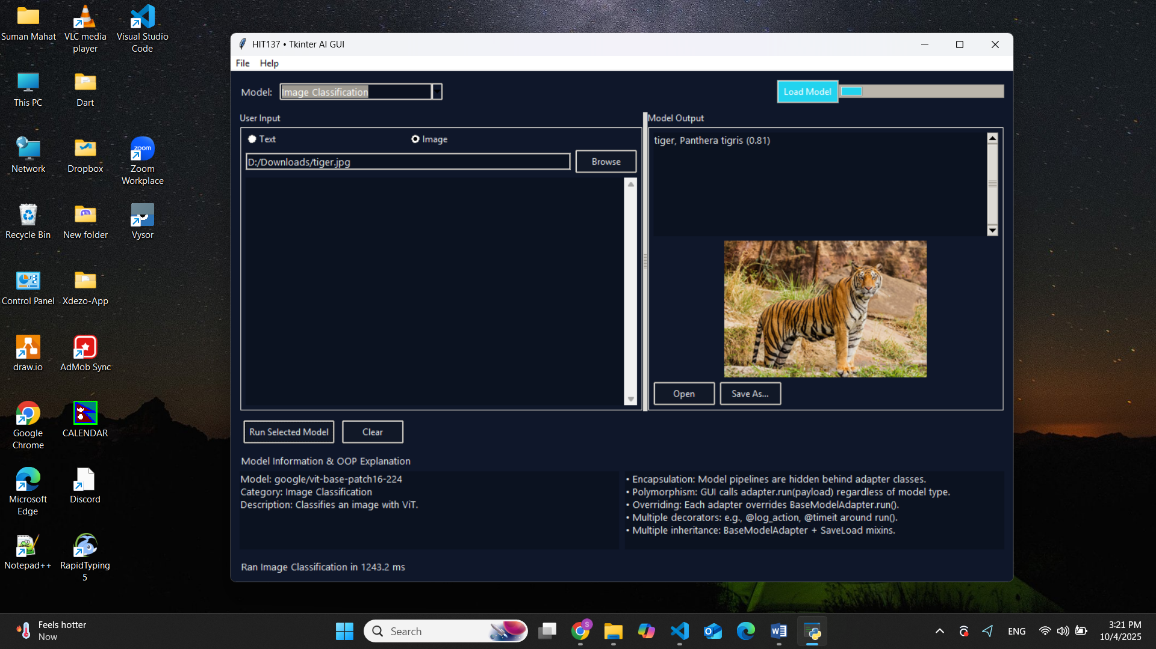

Figure 4: Image Classification Model Output

* **Model: Image to Text**

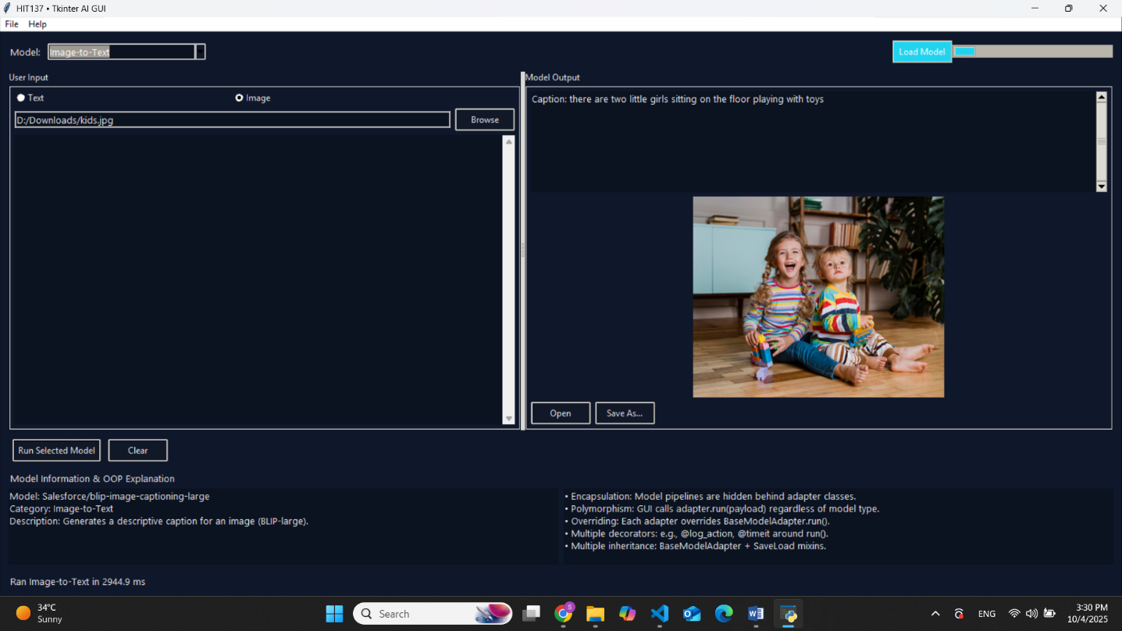

Figure 5: Image to Text Model Output (i)

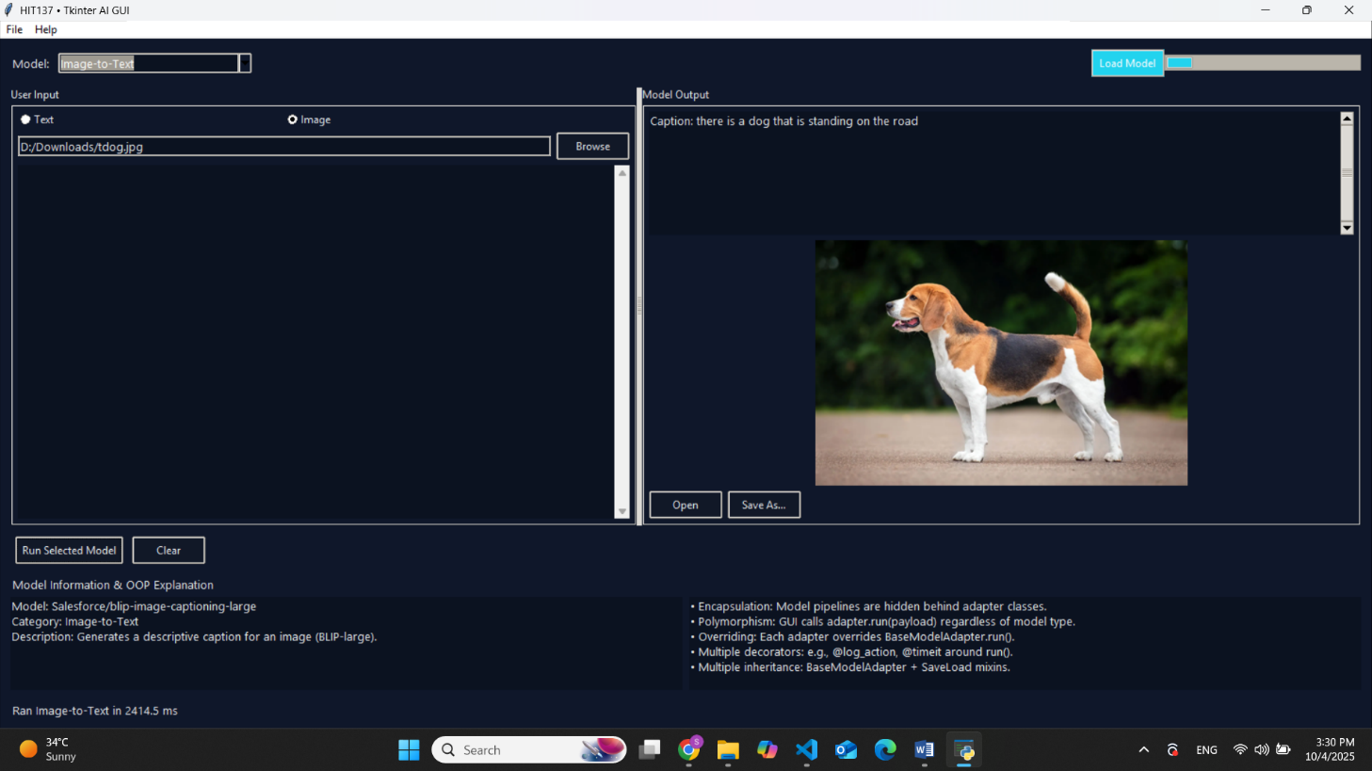

Figure 6: Image to Text Model Output (ii)

* **Model: Text to Image**

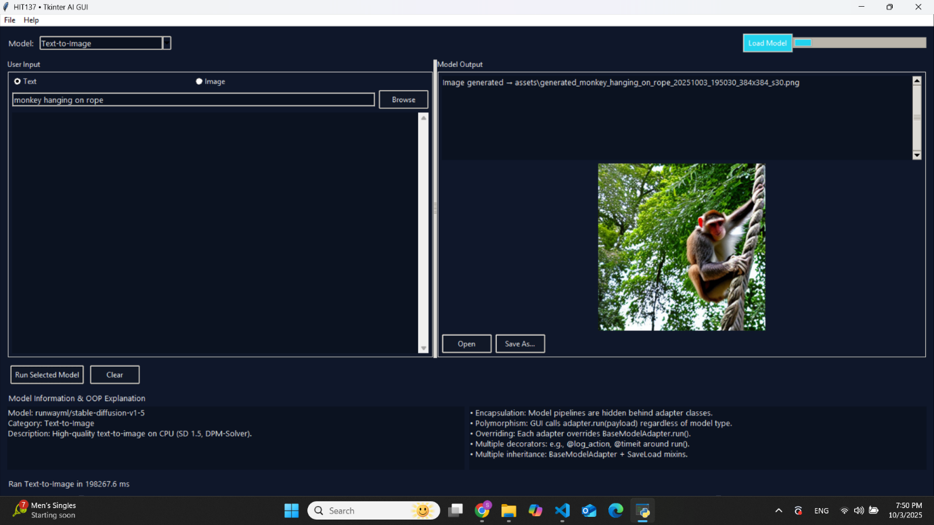

Figure 7: Text to Image Model Output (i)

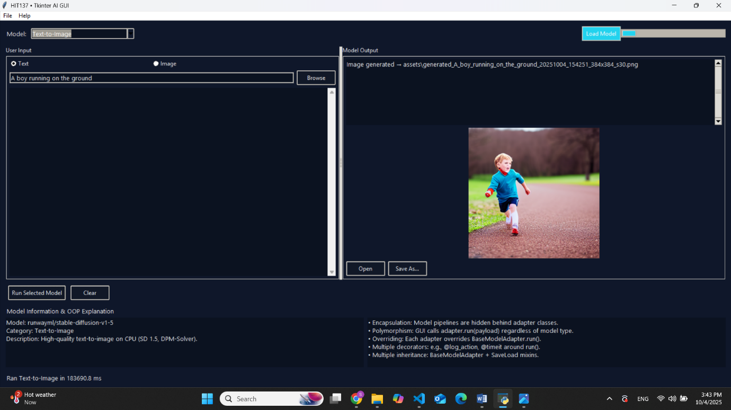

Figure 8: Text to Image Model Output (ii)

* **Model: Text to Video**

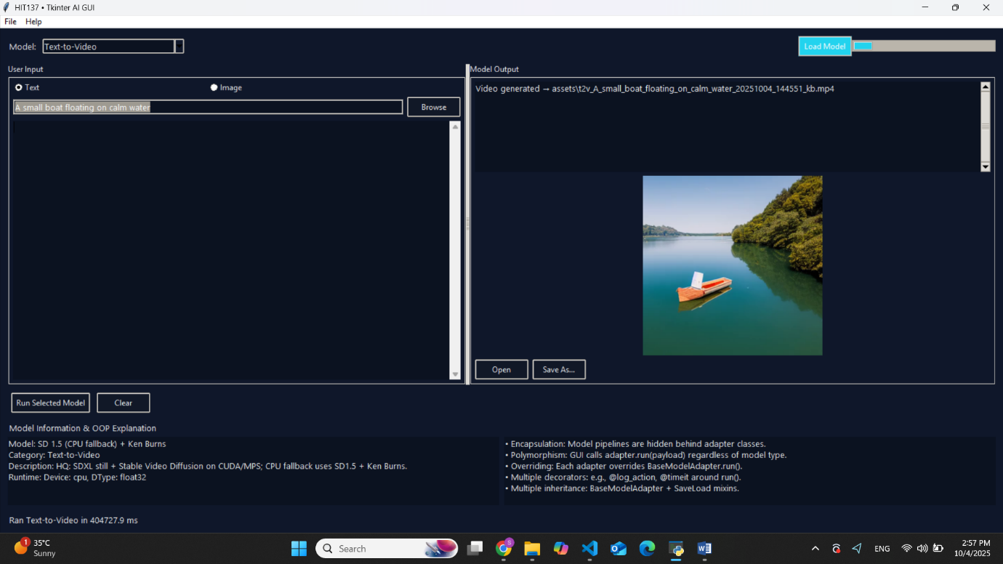

Figure 9: Text to Model Output (i)

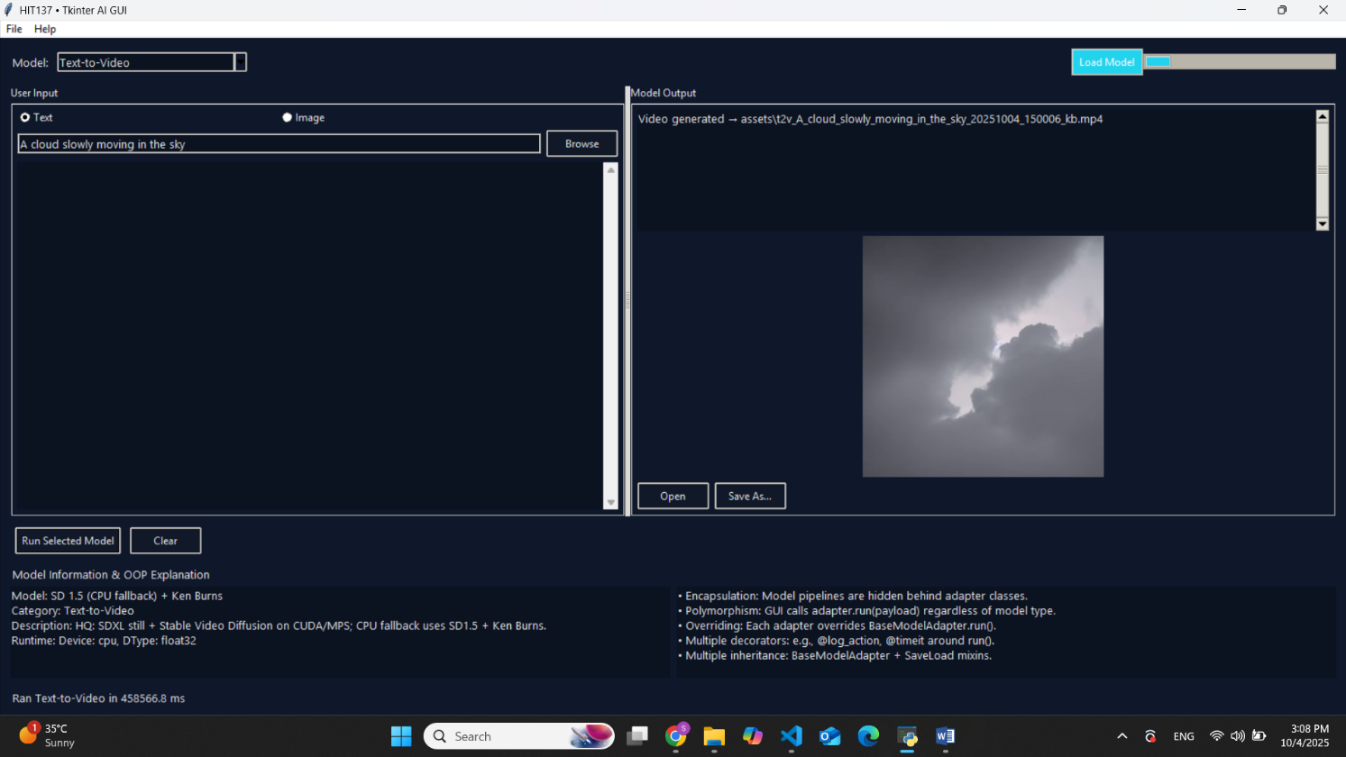

Figure 10: Text to Video Model Output (ii)

The generated video in MP4 format is available in the (MP4_Output) folder for viewing.